## Efficiency of light-emitting diode

### Theoretical background

The following method was used to determine the LED efficiency. The heat source (LED) is located at the center of a thin metal disk. The disk was painted in black to eliminate additional infrared reflections. Then the radial temperature distribution can be calculated using the following differential equation:

$\frac{d^{2}T}{dr^{2}}+\frac{1}{r}\frac{dT}{dr}=0$ (1)

The replacement $Z=\frac{dT}{dr}$ gives a new equation:

$\frac{dZ}{dr}+\frac{1}{r}Z=0$ (2)

Equation (2) can be directly solved

$$\frac{dZ}{Z}=-\frac{dr}{r}$$

$Z(r)=\frac{b}{r}$ (3)

After integrating equation (3) we get (4)

$T(r)=a+bln(r)$ (4)

The heat passing through the cross section of the disk (in the radial direction it has the shape of a vertical cylinder) is described by equation (5), where s - is the area of the lateral surface of the cylinder, t- time and χ – coefficient of thermal conductivity.

$Q=χ\frac{dT}{dr}⋅s⋅t$ (5)

If we make in (5) following replacements: $\frac{dT}{dr}=\frac{b}{r}$ and $N=\frac{Q}{t}$, then can derive (6), where h - thickness of disc.

$N_{thermal power of LED}=χ2πhb$ (6)

In equation (6), parameter $b=\frac{ΔT}{Δln(r)}$– is a slope of line and can be derived from graph, which describes relationship between logarithm of radius and temperature.

Efficiency of diode can be calculated from formula $η=\frac{I∙U-N_{thermal power of diode}}{I∙U}∙100\%$, where $I∙U$ is a total electric power of the circuit. Of course, we do not consider additional heat losses. This means that the experiment somewhat overestimates the efficiency of the LED.

### Laboratory instrumentation

Laboratory is using following equipment: heat camera, disk, light diode, relay, power supply, and Arduino board.

Visual representation of disk used for calculations is on Figure 1.

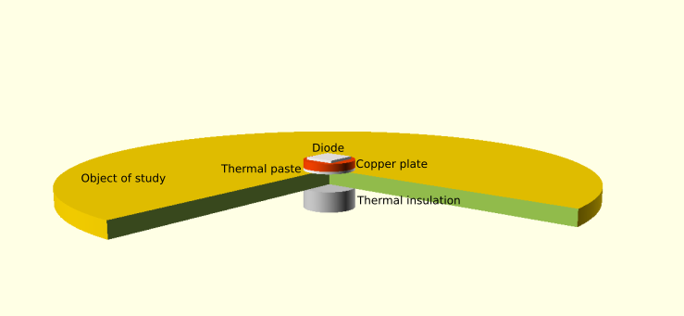

Figure 1 - Disk for heating

Under disk, there is light diode, which is connected to relay which is used to turn power on and off. Relay is also connected to power supply and Arduino UNO rev3 board which receives commands (turning relay on/off) through USB port. Simplified diagram of laboratory structure is described on Figure 2.

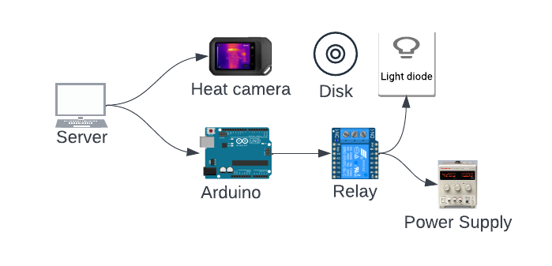

Figure 2 - Hardware components for diode laboratory

### How to use laboratory

Steps to use laboratory:

* Start diode efficiency lab.
* Heat camera streaming starts automatically and can be seen on website.
* Graph will be plotted that visualizes pixel values on horizontal line in the middle of image in real-time.
* Turn on power supply and wait for diode to heat up disk.
* Wait 15-20 min until temperature does not change results. Turn off power supply.
* Save measurement results and leave diode efficiency lab.
* Using data acquired from lab, draw graph, and calculate value of slope.
* Calculate diode efficiency of diode using predefined I, U, and slope from the graph.

The temperature can be calculated in this way. The user takes the maximum and minimum temperature values from the side scale. The maximum temperature value corresponds to a pixel value of 255 (white color) on the intensity scale, and the minimum temperature value corresponds to pixel value of 0 (black color).